Guidance for Completing Application Forms
  - CM-SM roles
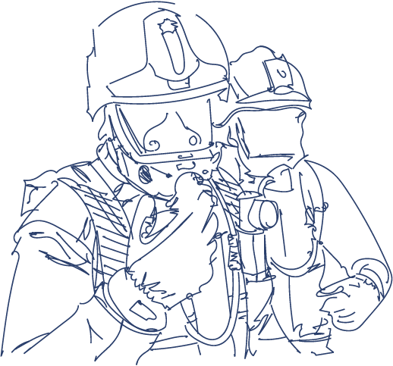
Ownership: Employee Resources Team (ERT)
Date Issued: 31/7/2025
Version: v1
Status: Draft

Contents
Introduction 3
Purpose and supporting data 3
How this guidance supports our values 3
Guidance for Structuring Application Evidence 4
1.Understand the Criteria 4
2. Use a Clear Structure 5
3. Tailor Evidence to the Role Level 6
4.Provide Strong, Relevant Examples 6
5. Highlight Outcomes and Impact 7
6. Be Concise and Stay Within Word Limits 7

Introduction
This guidance has been developed to support colleagues preparing application evidence for promotion within West Yorkshire Fire and Rescue Service, from Firefighter to Station Manager. It provides a clear and structured approach to presenting your skills, experience, and behaviours in a way that aligns with the expectations of each leadership level.
Promotion within the service is not only a recognition of past performance but also a demonstration of readiness to take on greater responsibility. As you progress from Firefighter to Station Manager, the nature of your role shifts from operational delivery to leadership, decision-making, team and resource management, and strategic contribution. This guidance will help you reflect that transition in your application.

Purpose and supporting data

The purpose of this guidance is to help applicants to structure strong, relevant, and clearly evidenced responses when applying for promotion. Specifically, it aims to explain the shift in responsibility from firefighter to Station Manager and provide a consistent framework for presenting examples clearly and concisely, ensuring that applicants focus on their own actions and impact, rather than describing team activity.
Using recognised frameworks such as the STAR model (Situation, Task, Action, Result), this document encourages you to provide focused, evidence-based examples that highlight your competence, potential, and alignment with the Core Code of Ethics, NFCC Leadership Framework, and your service’s own values and behaviours.
Whether you are applying for your first leadership position or progressing into middle management, this guidance is designed to help you:
- Understand what assessors are looking for
- Present your evidence clearly and effectively
- Reflect the level of leadership and accountability expected at your target role
By following this approach, you can ensure your application provides assessors with the best possible insight into your suitability for promotion.

How this guidance supports our values
WYFRS Core Values
- Teamwork: We recognise everyone’s strengths and contributions, working effectively as one team.
- Integrity: We are trustworthy, act ethically, treating each other with dignity and respect.
- Learning: We learn all the time; we share knowledge and experiences, celebrating success.
- Responsibility: We are responsible, work positively and take ownership of the work we do.
- Communication: We share clear information, in ways everyone understands, having open discussions.
Core Code of Ethics for Fire and Rescue Services – our five ethical principles:
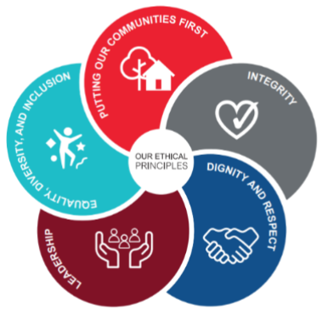
- Putting our communities first: We put the interests of the public, the community, and service users first.
- Integrity: We act with integrity including being open, honest, and consistent in everything that we do.
- Dignity and respect: We treat people with dignity and respect, making decisions objectively based on evidence, without discrimination or bias.
- Leadership: We are all positive role models, always demonstrating flexible and resilient leadership. We are all accountable for everything we do and challenge all behaviour that falls short of the highest standards.
- Equality, diversity, and inclusion (EDI): We continually recognise and promote the value of EDI, both within the FRS and the wider communities in which we serve. We stand against all forms of discrimination, create equal opportunities, promote equality, foster good relations, and celebrate difference.

Guidance for Structuring Application Evidence

1.Understand the Criteria
Read the Person Specification and Role Map carefully.
Identify the key competencies, such as:
- Command and leadership
- Health and safety
- Managing performance
- Equity, diversity & inclusion
- Collaboration and partnership working
- Learning and development
- Incident command

2. Use a Clear Structure
Use the STAR or CAR model to structure each response:
STAR Model
- Situation: Brief background or context
- Task: What were you responsible for?
- Action: What did you do? (Focus on your actions)
- Result: What was the outcome? Quantify/summarise impact

CAR Model (alternative)
- Context: Set the scene
- Action: What did you do and how?
- Result: What difference did it make?

Use first person ("I") throughout and focus on your contribution, even when describing team efforts.

3. Tailor Evidence to the Role Level
Show how your experience aligns with the level of responsibility required for the new rank (e.g. Crew Manager, Watch Manager, Station Manager).
When applying for promotion from Firefighter to Crew Manager, your application should focus on demonstrating that you're ready to step into a first-level leadership role, with an emphasis on supervisory skills, operational competence, communication, and team development. You're moving from being part of the team to leading the team, and your evidence should clearly reflect that transition.
When applying for promotion from Crew Manager to Watch Manager, your application should focus on demonstrating leadership, team development, and managing incidents or initiatives.
When applying for promotion from Watch Manager to Station Manager, your application should focus on demonstrating strategic thinking, leadership and management, policy influence, and partnership working.

4.Provide Strong, Relevant Examples
Choose examples that are recent, relevant, and impactful.
Use a variety of scenarios:
- Operational incidents
- Projects or initiatives
- Community engagement
- Performance management
- Learning & development delivery

Where possible, link examples to:
- WYFRS behaviours
- NFCC Core Code of Ethics
- NFCC Leadership Framework

5. Highlight Outcomes and Impact
Demonstrate how your actions led to:
- Improved team performance or morale
- Enhanced safety or operational effectiveness
- Positive feedback from colleagues or public
- Measurable results (e.g. reduction in accidents, increased training uptake)

6. Be Concise and Stay Within Word Limits
Stick to word counts or character limits.
Try to avoid repeating the same example across multiple questions unless absolutely necessary.

